MENTAL REPLAY |  |  |  | REFLECTION |  |  |  |  | DATE
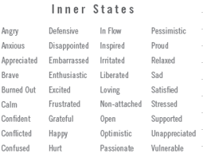

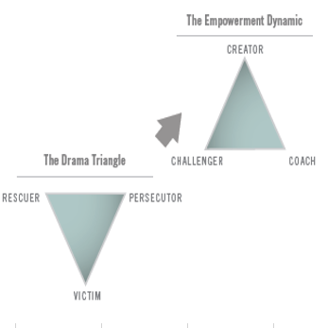
Situation  Describe what happened |  |  |  | My Thought  What I was thinking… |  |  | My Behavior  What I did and said…
Met with selected group of HR staff members to discuss preparing a response to a request made by President of HOC as to how HR can help them achieve their goals. He asked this question during a recent retreat wanting to get each support groups thoughts.  During the meeting one employee commented that a written response was not appropriate and felt a conversation would be better. Others felt that a written response was good but no one volunteered their thoughts as to how to proceed which left me to take the next steps. No committed actions coming from the group. |  |  |  | Little frustrated by the comment that a written response was not necessary. Why could you guys not see this opportunity and seize it? Is anybody going to step up show some leadership and help me put an outline together? |  |  | I stayed calm and said that I think a written summary type response is warranted along with a good robust conversation and that we can use this opportunity to review our HR game plan with the President. I challenged them to take my outline and flesh it out further.
Results  I saw this situation as an opportunity for us to show how we can add value to the business and to a certain extent drive our own game plan. I facilitated the discussion and committed to them I would provide a strawman in two days for the group to flesh out further. |  |  |  | My Inner State  I felt like I needed them to see the value of this exercise as an opportunity to demonstrate why we as business partners can bring value and impact.  I was disappointed with the lack of seizing the opportunity and some indifference. |  |  | My Mindset  Rescuer at first and then moved into a challenger mode and then into a coaching mode in helping finalize the product.
SELF-AUTHORING
Key Insight |  |  | Vison |  |  |  |  | 
One employee’s resistance to wanting to prepare a written response.  Lack of willingness by managers top step up and take the lead even though it was a request from the president of our largest business unit. |  |  | Someone in the meeting would have quickly come to my conclusion and led the charge that this is a great opportunity for us to demonstrate the value we can bring and to a certain extent define our future pathway.
 |  |  |  |  |  |  |  | Always set the stage in a situation of this nature as an opportunity and why it is important. This may trigger a better response.
 |  |  |  |  |  |  |  | Continue to work on instilling a vision and business case for projects of this nature. Challenge and coach the group to get to the desired end state.

